Project Group Meetings Agenda & Minutes

# Meeting 5

Date: 18 May 2025

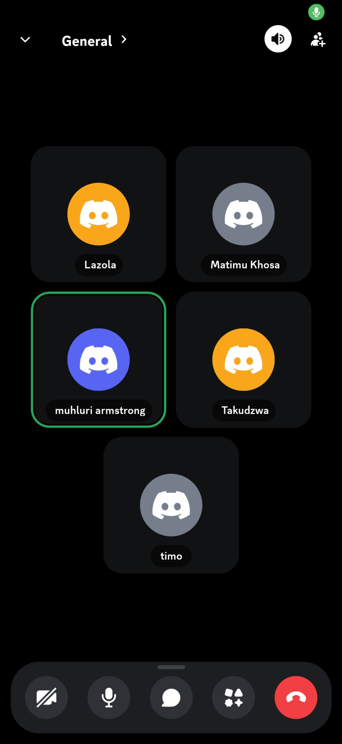

## Attendance:

- Timothy (Scrum Leader)  
- Lazola  
- Junior  
- Mhuluri  
- Steven (Late)

## Discussion Points:

1. Timothy asked members about the progress of their tasks.  
 - Junior: Completed his task.  
 - Mhuluri: Not done; struggling with CSV and PDF export extensions.  
 - Steven: Joked about being left out, mentioned remaining work (UI updates).  
2. Feature-specific discussion:  
 - Mhuluri: Forgot product filtering; will add it.  
 - Lazola: Updated UML diagrams; awaiting CSS implementation.  
 - Dashboard updates by Mhuluri are to be merged by Timothy.  
3. User Testing:  
 - Timothy: Got two users to test (buyers and sellers).  
 - Junior, Mhuluri, Steven, Lazola will each get one tester.  
4. Admin Email:  
 - Junior’s email used; Lazola may add his.  
5. Feature updates:  
 - Delivery option removed by Timothy.  
 - Steven to finalize price updates feature.  
 - AI feature preparation mentioned.

Meeting started at 21:00 and ended at 21:19.

# Meeting 4

Date: ____________________

## Attendance:

- Timothy (Scrum Leader)  
- Lazola   
- Junior  
- Mhuluri  
- Steven(Absent)

-Refiloe

## Discussion Points:

Discussion Points:  
1. Walking Tutor through website:

-Setup takes very long, we look very unprepared.  
 -Mhuluri walks the tutor through the site whilst Timothy tries to explain, very tough as they are in different locations and Mhuluri’s discord mike is not working.

- Tutor says our css could be better and we should remove any things that we will not be using.  
2. Comments from the tutor:

-He will be marking us as lucky would on monday.

-Basically al features should be done by Monday

Meeting started at 15:00 and ended at 15:44.

# Meeting 3

Date: 15 May 2025

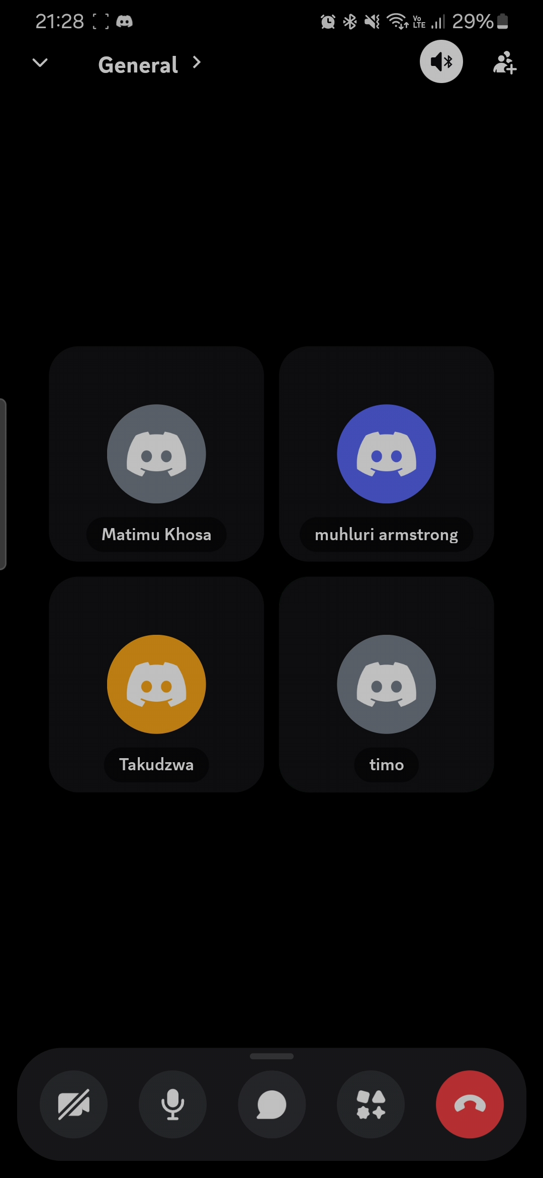

## Attendance:

- Timothy (Scrum Leader)  
- Lazola  
- Junior  
- Mhuluri  
- Steven (Late)

## Discussion Points:

1. Checkup:  
   Timothy asks how far everyone is:
   1. Mhuluri: "I fixed the range functionality of the dashboard filtering and I will check out why it was crashing on other devices"
   2. Timothy: "The database structure is making it harder for me to implement my track orders feature" (this is discussed for the majority of the meeting)
   3. Junior: "Why do u not just add a status field for each product in an order" (Timothy disregards this idea since it is from Junior)
   4. Steven: "Why do u not just add a status field for each product in an order"
   5. Timothy: "Great idea"
2. Progress updates:
   1. Junior: "Fixed css for the cart and removed cart from the image and put it on the navigation bar instead"
   2. Steven: "I will remove delivery and I will implement the AI with Junior"
3. Meeting started at 21:00 and ended at 21:28.

# Meeting 2

Date: ____________________

## Attendance:

- Timothy (Scrum Leader)  
- Lazola  
- Junior  
- Mhuluri  
- Steven (Late)

## Discussion Points:

Discussion Points:  
1. ____________________  
2. ____________________  
3. ____________________

# Meeting 1

Date: ____________________

## Attendance:

- Timothy (Scrum Leader)  
- Lazola  
- Junior  
- Mhuluri  
- Steven (Late)

## Discussion Points:

Discussion Points:  
1. ____________________  
2. ____________________  
3. ____________________